Charity football match
FOOD
BAKE SALE AND THERE WILL BE A BBQ WITH BURGERS AND HOT DOGS.

Price 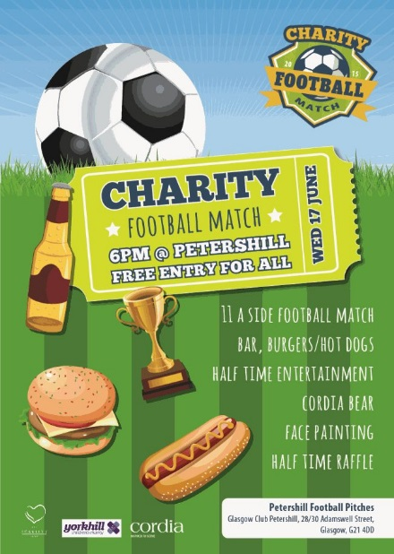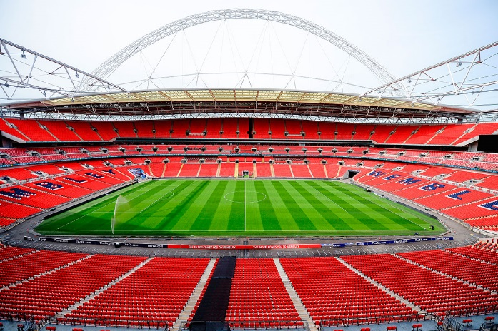
£20 per adult
£15 per child
The venue

The venue will be at Wembley because we are sponsored by ee. We will be aloud to haijue a capacity of 30,00 BEYOND SPORT – QUALITY EDUCATION AND EMPLOYMENT

